**Insert your school nameSemester One Examination, 2016**

**ATAR MODERN HISTORY**

|  |  |  |
| --- | --- | --- |
| **DocumentSet** | **Area of Study** | **RelatedQuestion** |
| 1 | Australia 1918-1955 (the end of World War One to the A.L.P Split) | 1 |
| 2 | Australia 1918-1955 (the end of World War One to the A.L.P Split) | 2 |
| 3 | Russia and the Soviet Union 1914-1945 (World War One to the end of World War Two) | 1 |
| 4 | Russia and the Soviet Union 1914-1945 (World War One to the end of World War Two) | 2 |
| 5 | China 1935-1989 (The Long March to the Tiananmen Massacre) | 1 |
| 6 | China 1935-1989 (The Long March to the Tiananmen Massacre) | 2 |

**DOCUMENT BOOKLET**

**Document Set 1:**  **Australia 1918-1955**

**THESE SOURCES RELATE TO QUESTION 1**

**Source 1**

Cover of a book released in 2001 by Bruce Duncan. Duncan is a Catholic priest who has studied economics and politics at Sydney University. He has written widely on social issues, including The Church's Social Teaching (1991), Crusade or Conspiracy: Catholics and the Anti-communist Struggle in Australia (UNSW Press, 2001), and in 2012, Social Justice: fuller life in a fairer world.

The cover shows key Bishops and Archbishops of Melbourne including Daniel Mannix and a lithograph portrait of B.A. Santamaria.

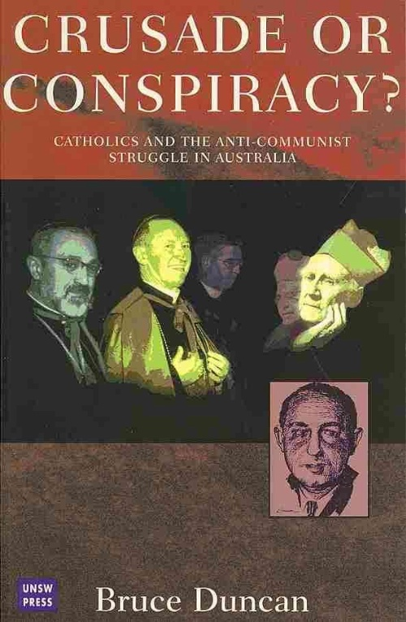

**Source 2**

Extract from a lecture by Arthur Gietzelt a former senior vice-president of the Australian Labor Party and was a Minister in first and second Hawke Labor governments. This is the text of his lecture to the Evatt Foundation of 21 November 2004.

‘In Defence of Dr Herbert Evatt - a great Australian.

“It is just fifty years, the October Labor Day weekend of 1954, since the Honourable Dr H V Evatt put the spotlight on an incubus, obnoxious and underground group that had for many years white-anted and weakened the labour movement. He put the searchlight on an 'outside organisation' that was using the trade union movement as the means of weakening federal Labor. He 'outed' an organisation that, with the blessing of the Catholic hierarchy and led by Mr B A Santamaria, was using the Australian Labor Party (ALP) as a means to fight the 'socialist' aspirations of the Australian labour movement. As the Communist Party was prominent in many unions, this led to the formation of 'Industrial Groups' to fight them. In this process, the hierarchy used the Catholic Social Studies Movement and other church bodies to enter the party-political arena, contrary to Vatican policy. By 1953 these Catholic groups were within an ace of capturing Australia's oldest political party. It is clear they used the 'communist bogey' to achieve a much wider perspective.

Various commentators suggest that the statement by the leader of the ALP, Dr Evatt, was a personal aberration, unnecessary, and should have been avoided. Some sources have even suggested he was eccentric and misguided, and, given a different leadership role, the later events could have been avoided. Nothing could be further from the truth. Not only is this historically incorrect, it masks a major contradiction within the labour movement that remains unresolved.”

**Source 3**

Cartoon by John Firth, published in March 1955 in *The Herald* entitled ‘Party Unity?’

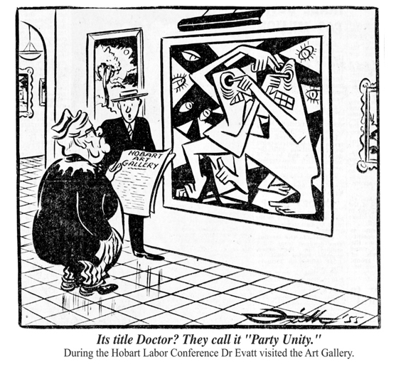

**Source 4**

Extract from an article by Paul Strangio a co-organiser of the Great Labor Split: Fifty Years Later and co-editor of The Great Labor Schism: A Retrospective, Scribe, 2005 published on www.EurekaStreet.com.au.

‘You’re a fanatic.’ ‘You’re not a Labor man.’ ‘Rat!’ So the interjections rang out with intensifying ferocity late on the evening of 19 April 1955 as F.R. (Frank) Scully, MLA for Richmond and until three weeks earlier a member of John Cain’s Labor ministry, addressed the Victorian Legislative Assembly in support of a no-confidence motion in the Cain Government. At 4.30am the following morning, Scully and his fellow Labor renegades voted with the Opposition parties to seal the Cain Government’s fate. Thus the Labor split of 1955 reached its point of no return; federally, it would be 17 years before the ALP regained office, while in Victoria, the eye of the storm, the penance lasted a generation…

Last month, on the 50th anniversary of that momentous debate, Scully, a sprightly 85-year-old, returned to its scene to launch the Great Labor Split: Fifty Years Later conference. This time there were no insults, but a hushed silence from the hundred-plus registrants who were acutely aware of a moment rich in historical resonance. To add piquancy to the occasion, sharing the launch duties was another octogenarian and Split survivor, Robert Corcoran. In the 1950s, Corcoran had been one of the earliest whistleblowers on B.A. Santamaria’s clandestine anti-communist organisation, the Catholic Social Studies Movement (‘the Movement’).

**END OF DOCUMENT SET**

**Document Set 2:**  **Australia 1918-1955**

**THESE SOURCES RELATE TO QUESTION 2**

**Source 1**

Curtin: 'No offence, mum, but I'm shifting to these here apron strings - at least for twenty-four hours' cartoon by John Frith. *The Bulletin* 31 December 1941.

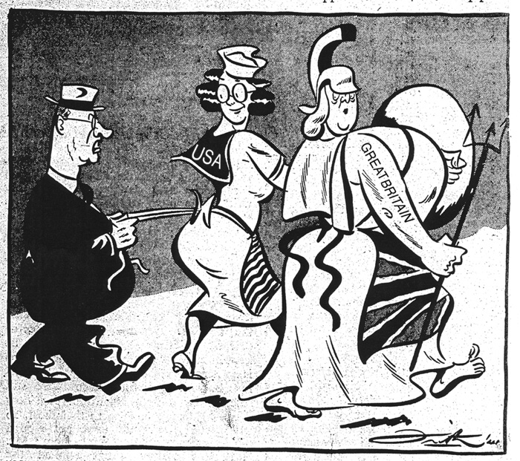

**Source 2**

Extract from the speech “The Task Ahead” by Prime Minister John Curtin. First published in *The Herald* (Melbourne), 27 December 1941

“…we refuse to accept the dictum that the Pacific struggle must be treated as a subordinate segment of the general conflict. By that it is not meant that any one of the other theatres of war is of less importance than the Pacific, but that Australia asks for a concerted plan evoking the greatest strength at the Democracies' disposal, determined upon hurling Japan back.

The Australian Government, therefore, regards the Pacific struggle as primarily one in which the United States and Australia must have the fullest say in the direction of the democracies' fighting plan.

Without any inhibitions of any kind, I make it quite clear that Australia looks to America, free of any pangs as to our traditional links or kinship with the United Kingdom.

We know the problems that the United Kingdom faces. We know the constant threat of invasion. We know the dangers of dispersal of strength, but we know too, that Australia can go and Britain can still hold on. ...”

**Source 3**

A map depicting a [believed to be] faked plan for a Japanese landing in Australia during World War II. The map originated in Australia's delegation to Chungking (China) 1942 and was rightly not regarded as genuine by the Australian Military though may have been accepted by Australian Prime Minister John Curtin.

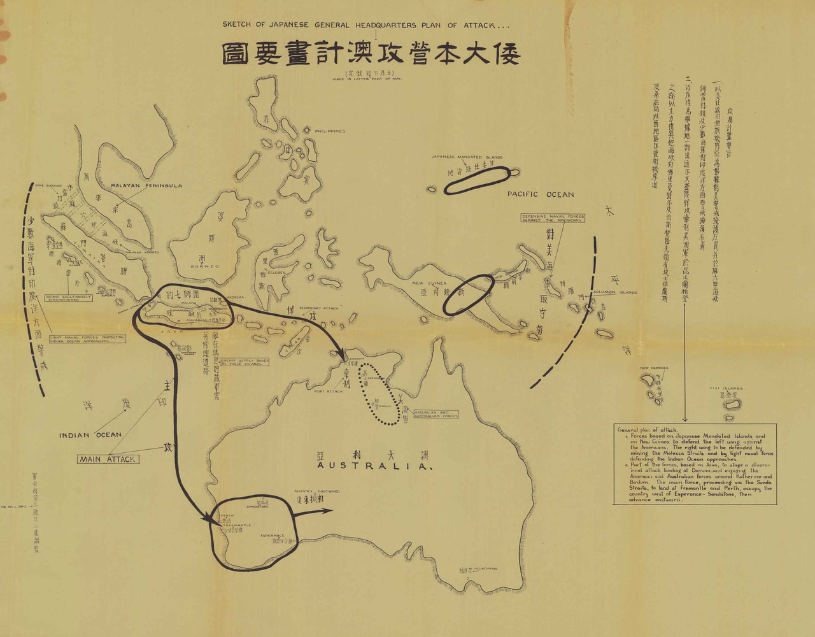

**Source 4**

Extract from a speech “He’s (not) coming South”: the invasion that wasn’t by Peter Stanley,

Principal Historian, Australian War Memorial. Dr Stanley promotes a revisionist campaign to deny the gravity of the danger faced by Australia in 1942 with regards to the possibility of a Japanese invasion. This paper was delivered at an Australian War Memorial conference in 2002 called "Remembering 1942".

“…Curtin felt the burden of responsibility of his office so gravely that it contributed to his death in 1945. His rejection of advice that invasion was not going to occur, his repeated appeals for reinforcements in secret communications, and his privately dwelling on the prospect suggest that he was unable to accept the reality.

…Curtin’s fruitless appeals for forces for Australia’s defence to Roosevelt and Churchill could have been avoided had they taken Curtin and MacArthur into their confidence. It was Curtin’s refusal to accept the strategic evaluations of London and Washington that caused his unease.

…In the event, Churchill and Roosevelt were right and Curtin was wrong. He has been represented as the “Saviour of Australia”. However much Australia’s contribution stemmed from his passionate commitment to victory, to his organisational skills and his personal example as an inspiring leader, Curtin did not save Australia from any real threat. Instead, one of the lasting legacies of his whipping up of the fear of invasion fear has been a persistent heritage of bogus invasion stories.”

**END OF DOCUMENT SET**

**Document Set 3: Russia and the Soviet Union 1914-1945**

**THESE SOURCES RELATE TO QUESTION 1**

**Source 1**

Propaganda photograph used and taken in "liberated" areas of Russia (USSR) that were under short term German reign, 1942.

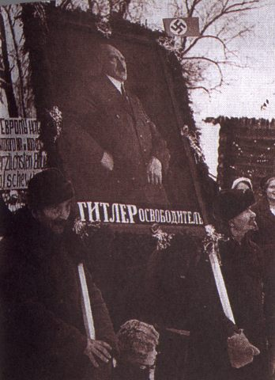

Caption on the poster reads “Hitler, the Liberator”.

**Source 2**

Extract from a speech by J. Stalin, July 3 1941

“…The war with fascist Germany cannot be considered an ordinary war. It is not only a war between two armies, it is also a great war of the entire Soviet people against the German-fascist armies. The aim of this national patriotic war in defence of our country against the fascist oppressors is not only to eliminate the danger hanging over our country, but also to aid all the European peoples groaning under the yoke of German fascism...

…Comrades, our forces are numberless. The overweening [showing excessive confidence or pride] enemy will soon learn this to his cost. Side by side with the Red Army many thousands of workers, collective farmers and intellectuals are rising to fight the enemy aggressor. The masses of our people will rise up in their millions. The working people of Moscow and Leningrad have already begun to form huge People’s Guards in support of the Red Army. Such People’s Guards must be raised in every city which is in danger of enemy invasion; all the working people must be roused to defend with their lives their freedom, their honour and their country in this patriotic war against German fascism…”

**Source 3**

Soviet Poster, 1942

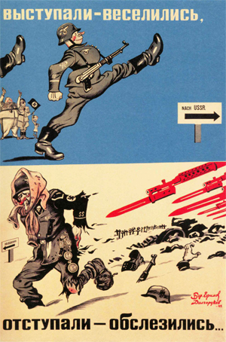

Caption reads “Started with joy, Retreated with tears”

**Source 4**

Extract from an article by John Erickson in *The Moscow Times*, My 5 1995. *The Moscow Times* is the only English-language weekly published in Russia.

“…Even now, over half a century later, this is a war [The Great Patriotic War} which is little understood...The selfless, sacrificial, almost unparalleled heroism of the people of the Soviet Union was obscured by the generation of official, stylized, stereotyped "heroic myths." The human cost was disgracefully concealed or politically manipulated, all to hide unpreparedness, incompetence and uncaring profligacy with human life on the battlefront.  
  
…Behind the Soviet front, a draconian regime either callously abandoned the populace, subjected it to inhuman coercion or demanded inordinate sacrifice, whether on the land, in the factories, or in the terrible siege conditions of Leningrad. It was not, as persistent propaganda proclaimed, that the institutions of the regime planned, managed and assured survival. Ironically, it was those ill-conceived practices and arbitrary methods of Stalin's rule which so frequently prejudiced survival and safety. What counted in the final analysis was the popular exercise of self-discipline, devotion to duty, responsiveness to leaders' demands and a deep attachment to true patriotism, a proper accounting of which has yet to be made for posterity.”

They comen there now, chasem

Round now, some

All run away

Right, prisonem whole lot,

Everyone

Tiem up longa trees….

And shootem whole lot, some

Feller, shootem, heapem up.

From the 1920’s childhood memories of elderly Walpiri.

**END OF DOCUMENT SET**

**Document Set 4: Russia and the Soviet Union 1914-1945**

**THESE SOURCES RELATE TO QUESTION 2**

**Source 1**

Painting entitled “Wounded” (2008) by Pavel Viktorovich Ryzhenko, a Russian artist, depicting the last Tsar on an inspection of a military hospital near the front in World War I.

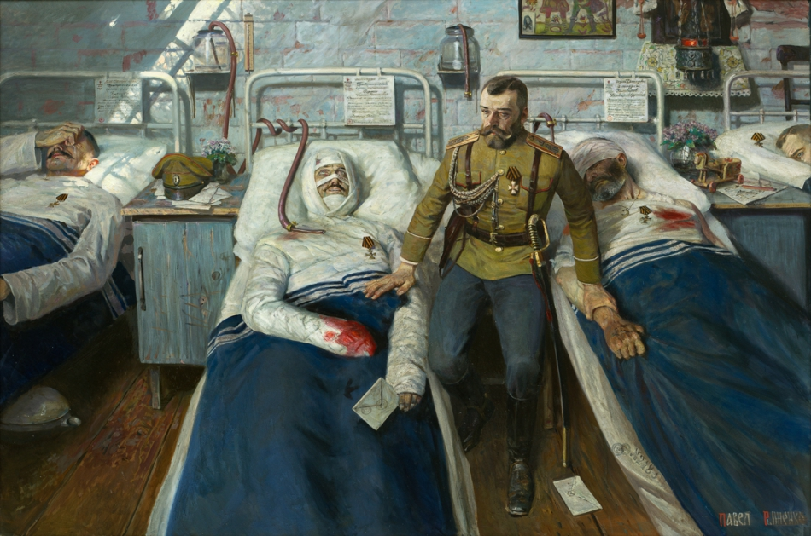

**Source 2**

Extract from ‘Memoirs of a British Agent’, by R.H Bruce Lockhart published in 1932.

“My recollections of those first war months in Moscow are remarkably vivid…I see again those moving scene at the station: the troops, grey with dust and closely packed in cattle trucks; the vast crowd on the platform…bringing gifts of flowers and cigarettes; fat priests to bless the happy warriors…Here was Russia…inspired by a patriotism…and an emotional religious fervour…

The decline in morale was, in fact, gradual, as it became clear that the war was to be long one… and although the Tsar’s loyalty to his Allies remained unshaken to the last, it was his failure to harness the loyalty of his own people which eventually cost him his throne…

The dissolution of the Duma provoked the usual strikes and protests. But [the Tsar’s] assumption of the Supreme Command [of the armed forces] was the first milestone on the way to [ruin]…It was the most fatal of [his] many blunders, for as Commander-in Chief he became personally responsible in the eyes of people for the long succession of defeats….

I found the atmosphere of St Petersburg more depressing than ever. Champagne flowed like water…The two best hotels were thronged with officers who should have been at the front. There was no disgrace in being a *‘shirker’…And in the streets there were long queues of ill-clad men and chattering women …waiting for the bread that never came.”

*‘shirker’ – a person who fails to meet their responsibility, someone who deliberately plans to escape their duties.

**Source 3**

Cartoon by [K. J. Chamberlain](http://spartacus-educational.com/ARTchamberlain.htm), [*The Masses*](http://spartacus-educational.com/ARTmasses.htm)*\*\** (January, 1915)

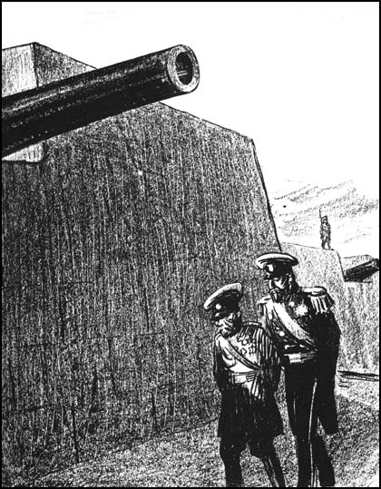

Russian Officer: Why these fortifications, your majesty?  
Surely the Germans will not get this far!  
The Czar: But when our own army returns....?

** *The Masses* was a socialist political magazine published in the United States between 1911 and 1917

**Source 4**

A report from the files of the Petrograd Security Police on the conditions and the mood in Russia, February to October 1916.

“The systematically growing disorganization of transport; the unrestrained orgy of pillaging and swindling of every kind of shady operators in the most diverse branches of the country’s commercial, industrial, and socio-political life; the unsystematic and mutually contradictory orders of representatives of state and local administrators;…the inequitable (unfair) distribution of food products and essential goods, the incredible rise in prices, and the lack of sources and means of procuring food among the presently starving population of the capital and large population centres….if we estimate the rise in earning as at 100 per cent, the prices of products have risen by 300 percent. The impossibility of even buying many food products and

necessities, the time wasted standing idle in queues to receive goods, the increasing incidence of disease due to malnutrition and unsanitary living conditionsMacintosh HD:Users:Rita:Desktop:pixel.gifMacintosh HD:Users:Rita:Desktop:pixel.gif (cold and dampness because of lack of coal and wood), and so forth, have made the workers, as a whole, prepared for the wildest excess of a “hunger riot.”

**END OF DOCUMENT SET**

**Document Set 5: China 1935-1989**

**THESE SOURCES RELATE TO QUESTION 1**

**Source 1**

Several hundred of 200,000 pro-democracy student protesters face to face with soldiers outside the Great Hall of the People in Tiananmen Square April 22, 1989.

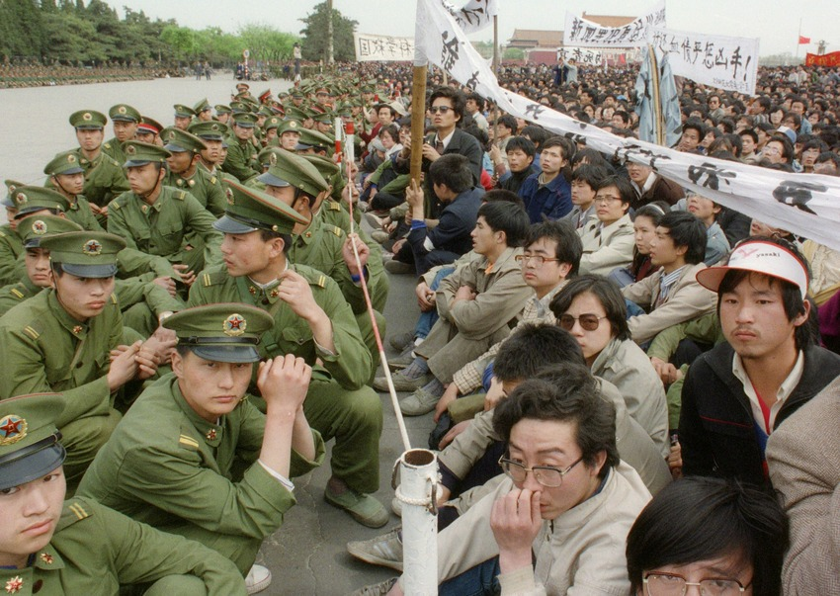

**Source 2**

Translated extract from a speech Li Peng at a meeting of cadres from party, government, and army organs of the central and Beijing municipal levels convened by the CPC Central Committee and the State Council on May 19 1989.

“…Comrades…calling on everyone to mobilize in this emergency and to adopt resolute and effective measures to curb turmoil in a clear-cut manner, to restore normal order in society, and to maintain stability and unity…the current situation in the capital is quite grim. The anarchic state is going from bad to worse. Law and discipline have been undermined… the vast numbers of young students are kindhearted, that subjectively they do not want turmoil, and that they have fervent patriotic spirit, wishing to push forward reform, develop democracy, and overcome corruption. This is also in line with the goals which the party and government have striven to accomplish.

The military vehicles on the road which you saw just now are those of the PLA troops entering the vicinity of Beijing Municipality a short while ago. This was done out of absolute necessity. It is because the police force in Beijing Municipality has been unable to maintain order in the Municipality…Thus, without a group of PLA entering here to maintain public order in Beijing Municipality, order, we believe, would be very difficult to restore.  
  
…That is to say that the PLA troops are compelled to enter the capital in order to restore the normal order in Beijing, maintain public security, and prevent important government organizations from being affected or stormed. I would like to explain this point clearly to all those who are present here. The PLA troops' arrival is definitely not aimed at dealing with the students. It is hoped that all trades and professions, people in various circles, and particularly people of the various democratic parties will support the PLA troops for their action to safeguard the capital and maintain public security. I hope that you will give them your full understanding and support.”

**Source 3**

Cartoon published in *The Washington Post*, June 6 1989.

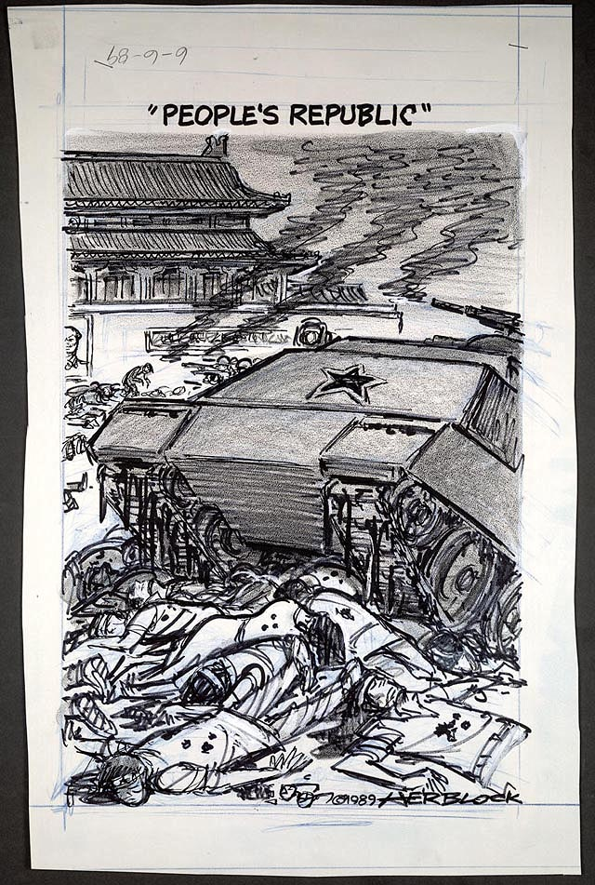

**Source 4**

Extract from an article published on Slate - ***Slate*** is a daily magazine on the Web. Founded in 1996, it is a general-interest publication offering analysis and commentary about politics, news, business, technology, and culture.

“This week marks the [20th anniversary](http://www.cbsnews.com/stories/2009/05/30/notebook/main5050927.shtml) of the 1989 Tiananmen Square massacre. Western media characterize the incident as a brutal government crackdown on peaceful protesters. What does the Chinese government say about it?

Very little. Neither the 1989 protests nor the ensuing massacre is included in Chinese textbooks, and many students today have never heard of these events. For the most part, the government avoids discussing the issue at all. The government does acknowledge that the People's Liberation Army intervened after seven weeks of demonstrations and that people were killed. But the official line is that, rather than crushing a peaceful protest, the military simply defended itself—and the country—against violent counterrevolutionary elements. ("Counter-revolutionary" is used in China in much the same way as "un-American" in the United States)…

…the government's attitude toward Tiananmen Square has [shifted](http://newsweek.washingtonpost.com/postglobal/pomfretschina/2009/05/chinas_changing_views_on_june.html) from counter messaging to dismissal. In 1990, then-General Secretary Jiang Zemin called the international controversy "much ado about nothing." In 2003, Premier Wen Jiabao referred to the incident as occurring "in the last century." Leaders now call it settled history and decline to elaborate…”

**END OF DOCUMENT SET**

**Document Set 6: China 1935-1989**

**THESE SOURCES RELATE TO QUESTION 2**

**Source 1**

Photograph showing Provincial Party Secretary Wang Yilun, being criticized by Red Guards from the University of Industry and forced to bear a placard with the accusation “counterrevolutionary revisionist element,” Harbin, China, August 23, 1966. The photograph was used on the front page of regional and nation-wide newspapers.

[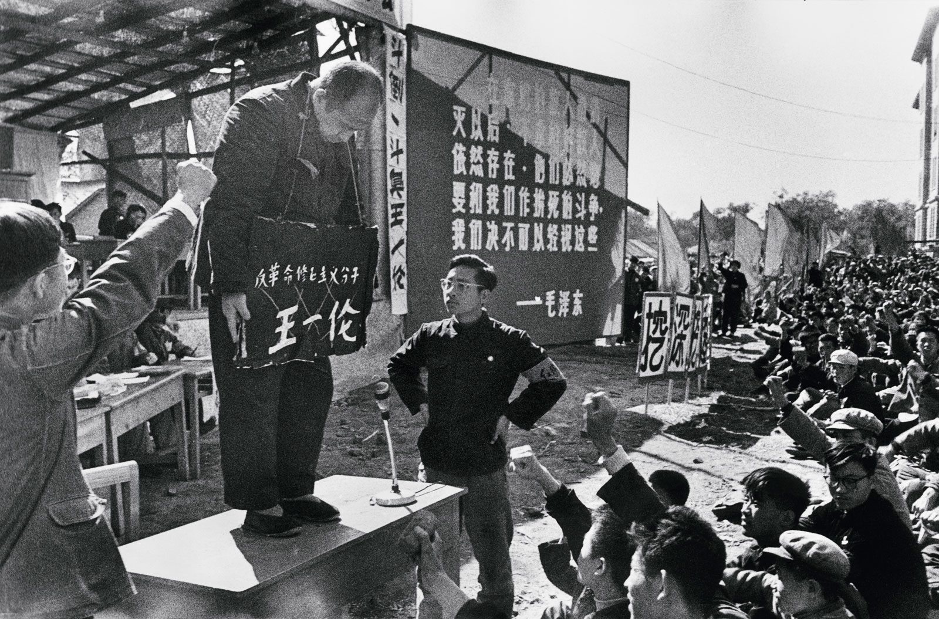](http://www.nybooks.com/wp-content/uploads/2016/01/li-zhensheng.jpg)

**Source 2**

Extract from the state-sanctioned magazine China Pictorial May 1969. The edition published an editorial column titled “The whole family is Red”

“…Before liberation, oppressed by the exploiting class, Ting Lai-yu’s family lived a life worse than that of beasts of burden. When he was 13, his parents died one after the other of poverty and illness. His five brothers and sisters either died of starvation or were sold. Within a year, Ting Lai-yu found himself the only survivor of the family…After liberation, Ting Lai-yu was emancipated and became master in his own house. He raised a new family and lived a happy life…Ting often teaches his children: Now that we are emancipated, don’t forget the Communist Party; we owe our happiness to Chairman Mao!

In March 1967, with the enthusiastic help of the People’s Liberation Army, a Mao Zedong Thought study class was set up in Ting Lai-yu’s family. This further promoted their ideological revolutionization and aroused an inexpressibly deep class feeling of loyalty to Chairman Mao. Every member, with the exception of Hung-ping who is less than three, can recite the “good old three” articles and over 100 quotations from Chairman Mao. Every bit they learn, they apply, combining study with application. The invincible thought of Mao Zedong is the life blood of the revolutionary people. They feel that in addition to studying and applying well Mao Zedong Thought themselves, they should also propagate it among more people…They disseminate Mao Zedong Thought with soaring enthusiasm, giving expression to their boundless love for and loyalty to the great leader Chairman Mao.”

**Source 3**

Poster produced by the Dongfanghong Industrial Factory 1967 – “Eliminate the Four Old - Establish the Four New"

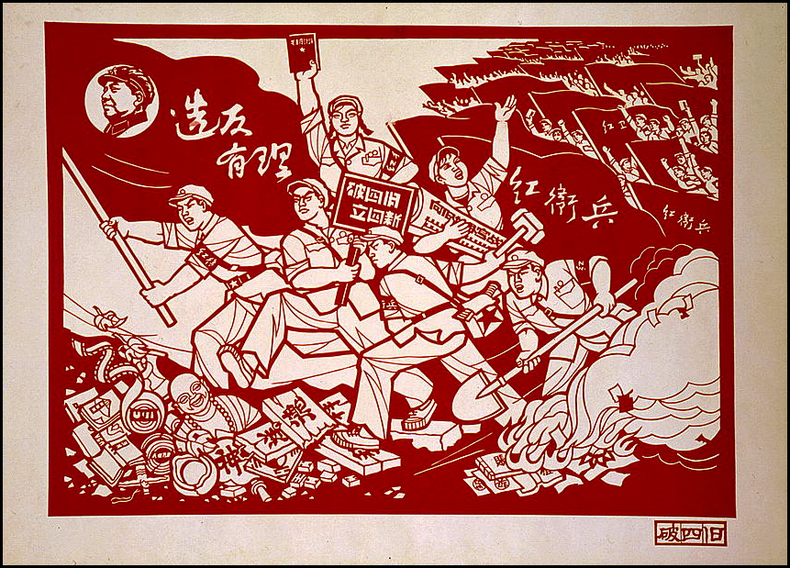

**Source 4**

Extract from a web page – Alpha History – Historiography of the Cultural Revolution. Alpha History is an Australian based group providing free and low cost resources to support the teaching, learning and study of history.

“…One of the first serious historical studies of the Cultural Revolution was undertaken by Hong Yung Lee (The Politics of the Chinese Cultural Revolution, 1978). In this work, Lee argued that the Cultural Revolution began as a conflict between party elites, but expanded rapidly into conflict between elites and the masses. Lee suggested that most of the Red Guards were from underprivileged sections of urban society. They were aggrieved because the Revolution had failed to meet their needs. The Red Guards were thus motivated by frustration and class envy more than political or ideological concerns. The communist regime had established a precedent for ‘violent criticism’ during the ‘Speak Bitterness’ campaigns that accompanied land reform. According to Lee, Mao set this movement in motion but was unable to control or restrain it.”

**ACKNOWLEDGEMENTS**

**Document Set One**

**Source 1** Crusade or Conspiracy. Retrieved March 2016 https://theconversation.com/profiles/bruce-duncan-90566

**Source 2** Support for Evatt. Retrieved March 2016

http://evatt.org.au/papers/defence-dr-herbert-vere-evatt.html

**Source 3** Cartoon ALP Split. Retrieved March 2016

http://frith.moadoph.gov.au/the-best-of/6-party-unity/

**Source 4** Fiftieth Anniversary of the ALP Split. Retrieved March 2016. http://www.eurekastreet.com.au/article.aspx?aeid=398#.VxHB6CBXrVI

**Document Set Two**

**Source 1** Curtin’s move to America. Retrieved may 2016

http://john.curtin.edu.au/artofthepossible/leaders.html

**Source 2** The task ahead speech. Retrieved May 2016 http://john.curtin.edu.au/pmportal/text/00468.html

**Source 3** Plans for the Japanese invasion of Australia. Retrieved May 2016

https://www.awm.gov.au/sites/default/files/media

**Source 4** Criticisms of Curtin. Retrieved May 2016 https://www.awm.gov.au/sites/default/files/media/conference/2002/stanley_paper.pdf

**Document Set Three**

**Source 1** Anti-Soviet propaganda. Retrieved March 2016

http://englishrussia.com/2007/05/20/german-anti-soviet-and-anti-jewish-posters-on-russian/

**Source 2** Stalin’s speeches on the Great Patriotic War. Retrieved March 2016.

https://www.marxists.org/reference/archive/stalin/works/1941/07/03.htm

**Source 3** Soviet propaganda during WW2. Retrieved April 2016,

http://www.allworldwars.com/Russian%20WWII%20Propaganda%20Posters.html

**Source 4** Retrospectives on the Great Patriotic War. Retrieved April 2016

http://www.themoscowtimes.com/news/article/tmt/339657.html

**Document Set Four**

**Source 1** Tsar and army command. Retrieved May 2016

https://laststandonzombieisland.files.wordpress.com/2014/12/wounded-by-pavel-viktorovich-ryzhenko.jpg

**Source 2** Russia World War One on the home front. Retrieved May 2016

https://books.google.com.au/books?id=2cqXAwAAQBAJ&pg

**Source 3** Failure of the Tsar cartoon. Retrieved May 2016

http://spartacus-educational.com/FWWtsar.htm

**Source 4** Conditions in Petrograd during World War One. Retrieved May 2016

http://alphahistory.com/russianrevolution/police-conditions-in-petrograd-1916/

**Document Set Five**

**Source 1** Military and protestors Tiananmen Square. Retrieved March 2016

http://mashable.com/2014/06/04/tiananmen-square-massacre-photos/#i6m51M6RQiqQ

**Source 2** Chinese government response to Tiananmen Square. Retrieved March 2016

http://www.tsquare.tv/chronology/MartialLaw.html

**Source 3** Political cartoons Tiananmen Square. Retrieved March 2016.

https://www.loc.gov/exhibits/herblocks-history/ticktock.html

**Source 4** Retrospectives on Tiananmen Square. Retrieved March 2016

http://www.slate.com/articles/news_and_politics/explainer/2009/06/tussle_in_tiananmen_square.html

**Document Set Six**

**Source 1** Counter-revolutionaries in the Cultural Revolution. Retrieved May 2016

http://www.nybooks.com/daily/2016/01/26/china-surviving-camps-cultural-revolution-memoir/

**Source 2** Primary source material Cultural Revolution. Retrieved May 2016

http://alphahistory.com/chineserevolution/whole-family-is-red-1969/

**Source 3** Cult of personality and the Cultural Revolution. Retrieved May 2016 htt<ps://beyondthebubble.stanford.edu/assessments/chinas-cultural-rev>olution

**Source 4** Historiography of the Cultural Revolution. Retrieved May 2016

http://alphahistory.com/chineserevolution/historiography-cultural-revolution/

**END OF DOCUMENT BOOKLET**